1. What were the top 20 laptop combinations sold in 2015, per question 1? Dynamize the '20'

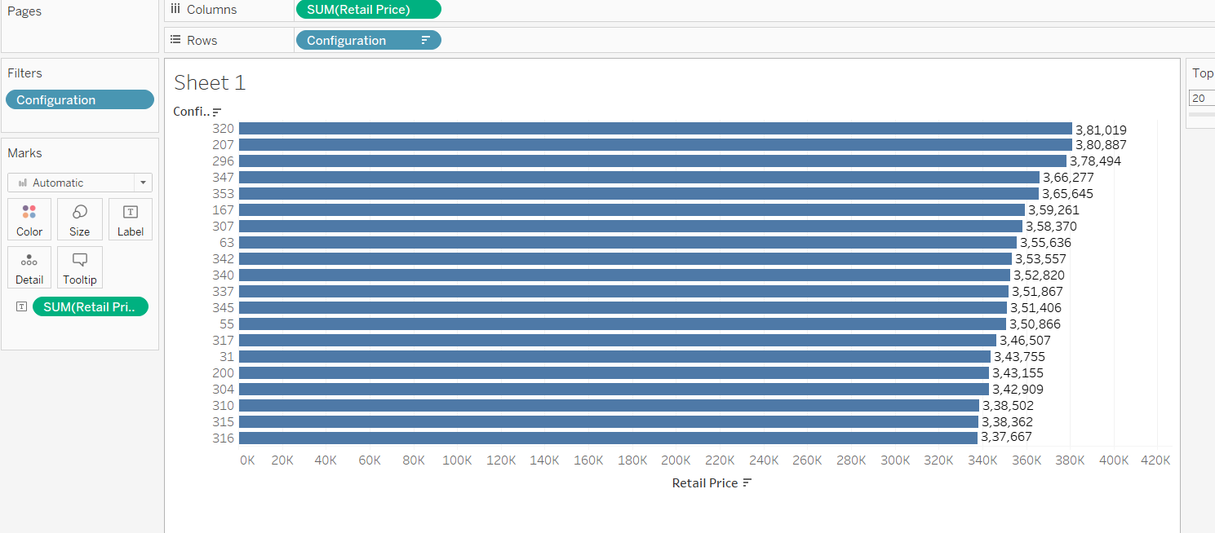

1. Has the average price for these top "20" laptops changed over time?

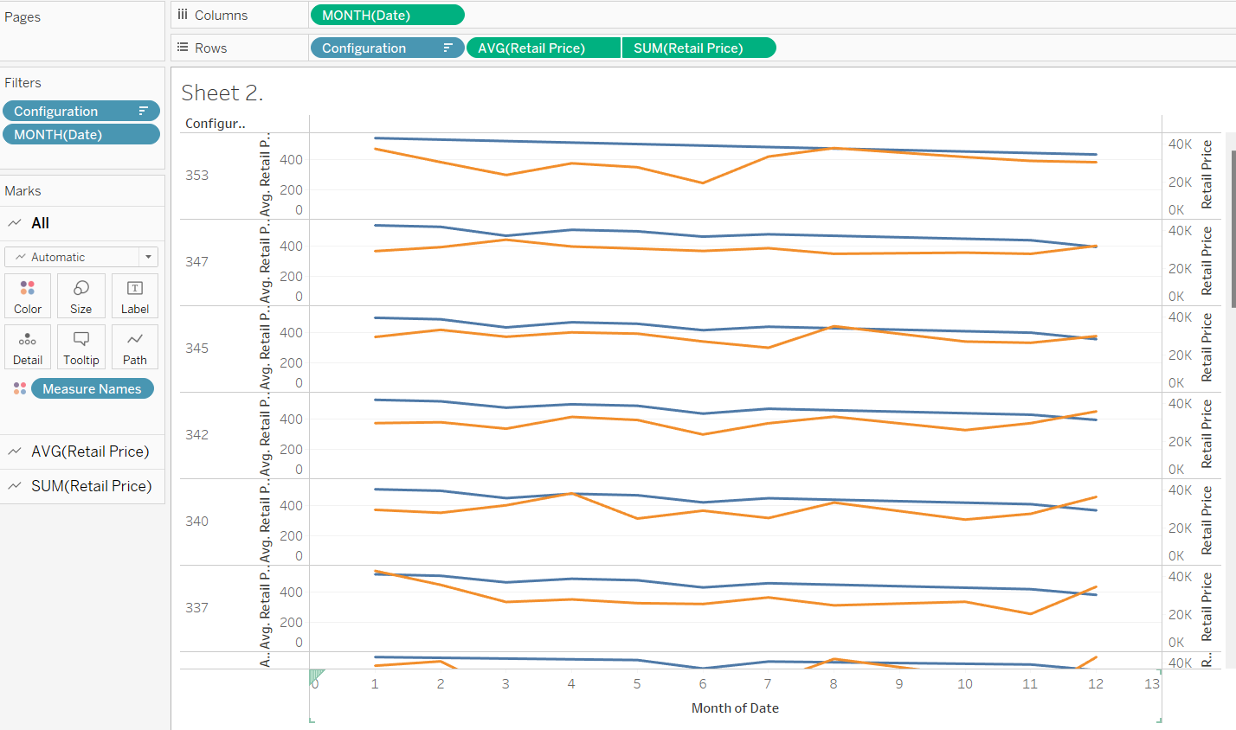

1. Across all 15 stores, are the average costs for these top "20" computers the same? (Apply filters using laptops)

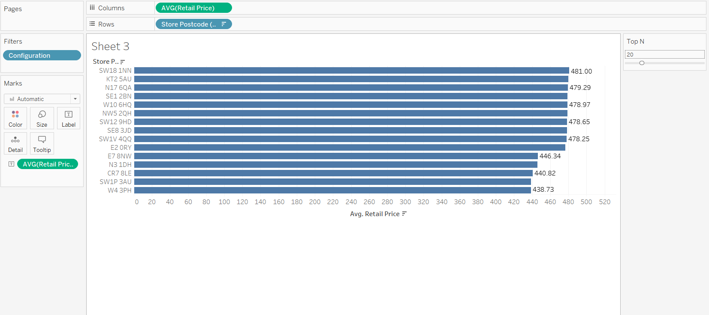

1. Does the sale of laptops vary by the month or the day of the month? (For instance, higher sales in December or lower sales towards the month's end)

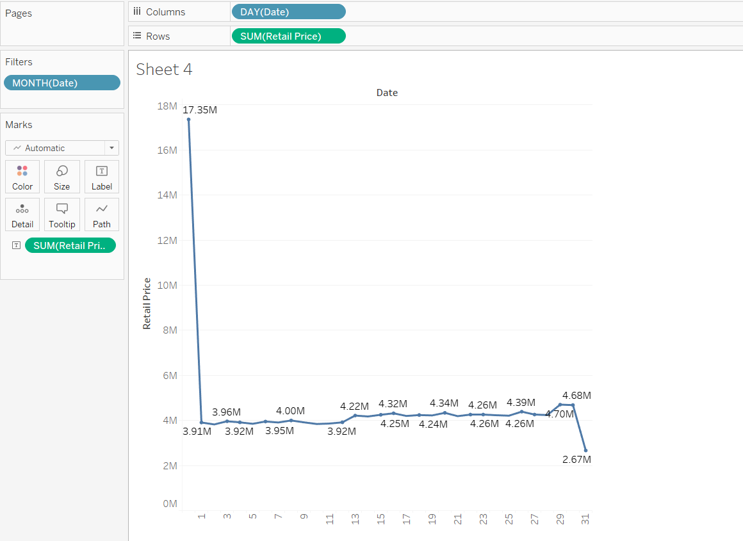

1. Do shops with lower average prices also sell more merchandise?

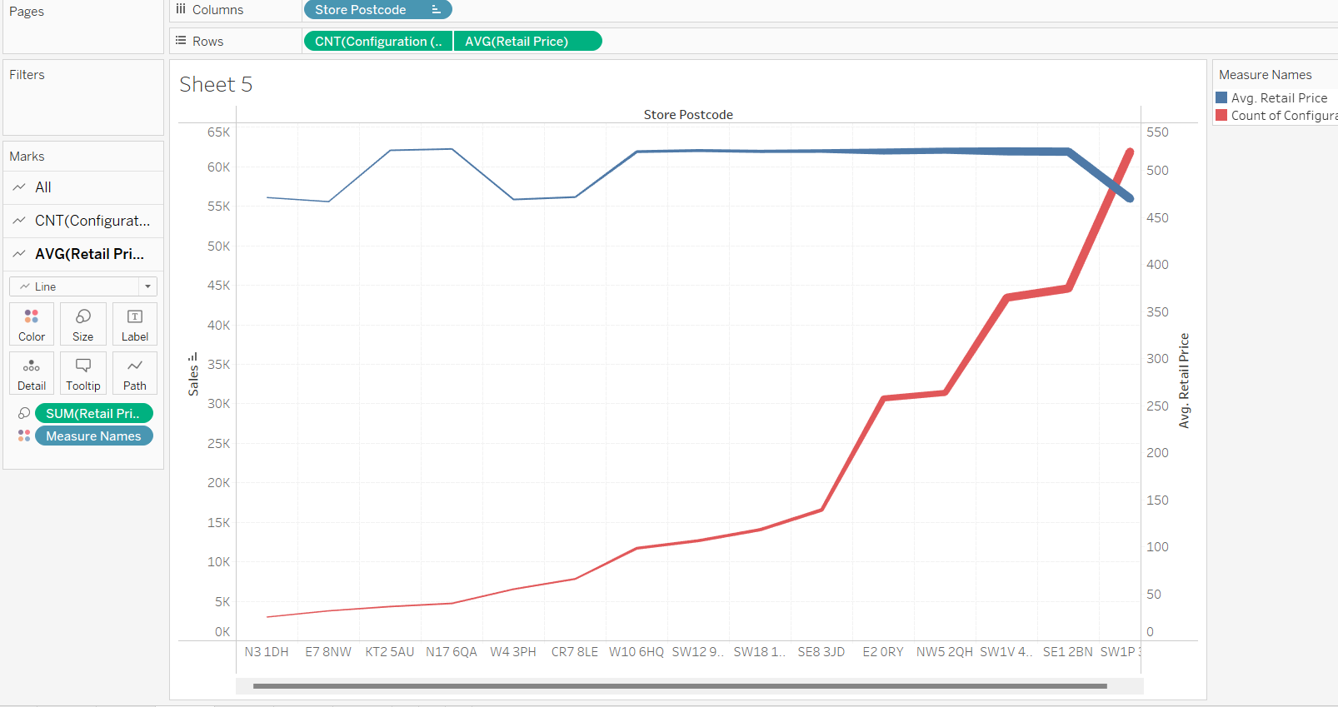

1. Reduce the 864 configurations to 32 configuration groups in answer to question 6. Create High-Low groups for each of the 5 configuration settings to do this. How are the 32 configurations' average prices different from one another? Use combined fields (hint: Combined fields)

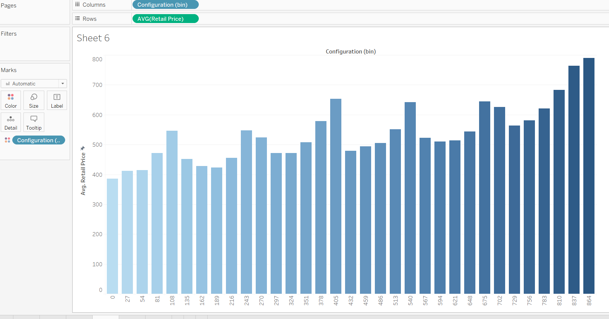

1. How far do shoppers typically drive to purchase laptops? (Establish the distance between a customer and a store and determine the typical distance travelled overall and for each store.Distance is equal to squared (COSX-OSX + COSY-OSY).

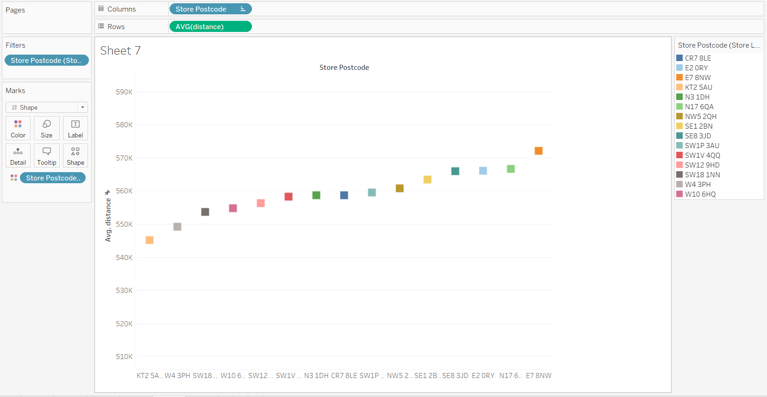

1. Does store proximity influence the store's ability to boost sales?

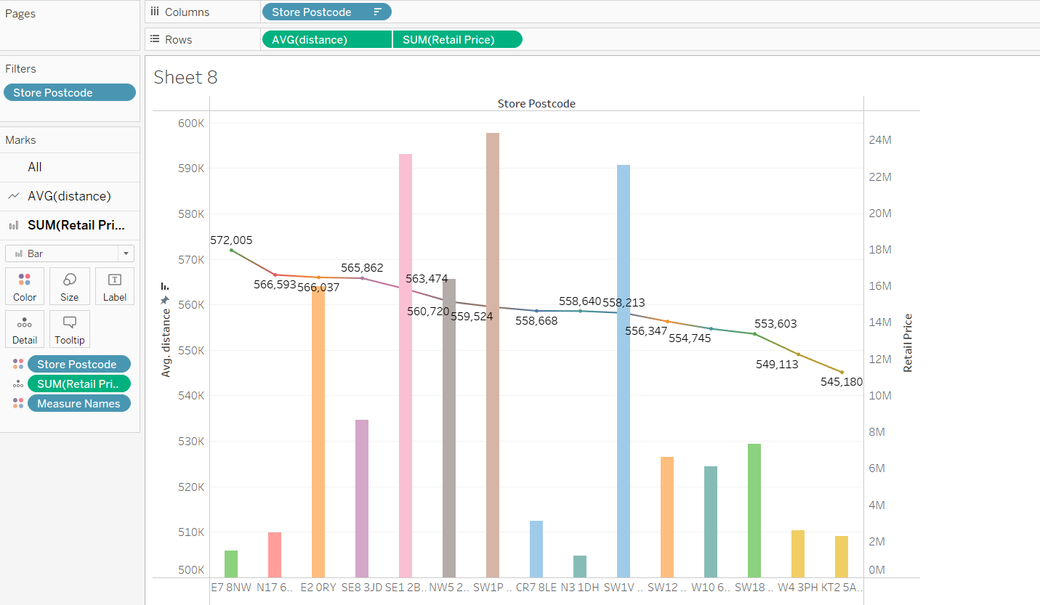

1. Include spreadsheets relating to Store numbers in a Store-view dashboard (use an interactive filter)

